**Komal Atif**

**53635**

**Lab 7**

**Practice task**

org 100h

.model small

.stack 100h

.data

msg1 DB 10,13, "Enter First Number$"

msg2 DB 10,13, "Enter Second Number$"

msg3 DB 10,13, "Numbers are equal$"

msg4 DB 10,13, "Numbers are not equal$"

.code

main proc

mov ax,@data

mov dx,ax

mov dx,offset msg1

mov ah,9

int 21h

mov ah,1

int 21h

mov cl,al

mov dx,offset msg2

mov ah,9

int 21h

mov ah,1

int 21h

mov dl,al

cmp dl,cl

je label 1

mov dx,offset msg4

mov ah,9

int 21h

mov ah,4ch

int 21h

label1:

mov dx,offset msg3

mov ah,9

int 21h

mov ah,4ch

int 21h

main endp

end main

ret

**Task 1**

Create an assembly program which takes your Marks in lab mid as input,

if your marks are less than 5 messages should be displayed “Need hard work”

else print “Satisfactory”.

**Program**

.model small

.stack 100h

.data

msg1 DB 10,13, "Enter your marks in lab mid: $"

msg2 DB 10,13, "Need hard work$"

msg3 DB 10,13, "Satisfactory$"

.code

main proc

mov ax, @data

mov ds, ax

mov dx, offset msg1

mov ah, 9

int 21h

mov ah, 1

int 21h

sub al, '0'

mov cl, al

cmp cl, 5

jl Less

mov dx, offset msg3

mov ah, 9

int 21h

mov ah,4ch

int 21h

Less:

mov dx, offset msg2

mov ah, 9

int 21h

mov ah, 4Ch

int 21h

main endp

end main

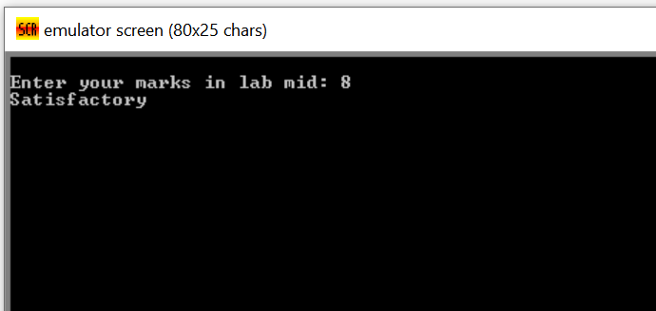

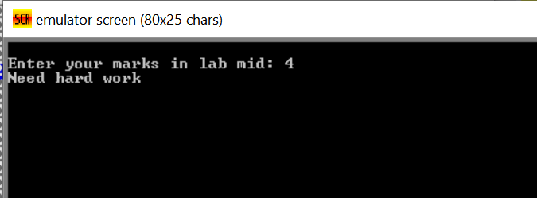

**Task 2**

Write an assembly language program that allow user to input one-digit number and

determine the number is positive or zero

**Program**

.model small

.stack 100h

.data

msg1 DB 10,13, "Enter a one-digit number: $"

msg2 DB 10,13, "The number is zero$"

msg3 DB 10,13, "The number is positive$"

.code

main proc

mov ax, @data

mov ds, ax

mov dx, offset msg1

mov ah, 9

int 21h

mov ah, 1

int 21h

sub al, '0'

cmp al, 9

cmp al, 0

cmp al, 0

je IsZero

mov dx, offset msg3

mov ah, 9

int 21h

mov ah,4ch

int 21h

IsZero:

mov dx, offset msg2

mov ah, 9

int 21h

mov ah, 4Ch

int 21h

main endp

end main

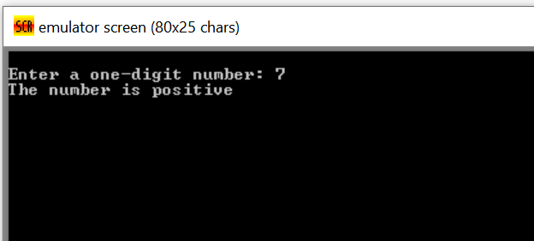

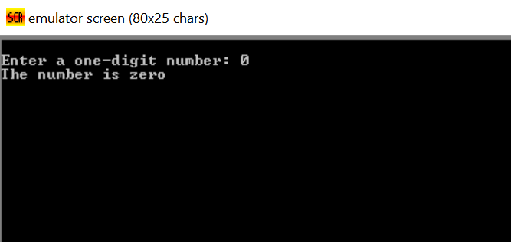

**Task 3**

Write an assembly language that compares the values A and B and prints a message if the

value in A is greater than B, less than B.

**Program**

.model small

.stack 100h

.data

msg1 DB 10,13, "Enter First Number A: $"

msg2 DB 10,13, "Enter Second Number B: $"

msg3 DB 10,13, "A is greater than B$"

msg4 DB 10,13, "A is less than B$"

.code

main proc

mov ax, @data

mov ds, ax

mov dx, offset msg1

mov ah, 9

int 21h

mov ah, 1

int 21h

sub al, '0'

mov cl, al

mov dx, offset msg2

mov ah, 9

int 21h

mov ah, 1

int 21h

sub al, '0'

mov dl, al

cmp cl, dl

jg Greater

jl Less

Greater:

mov dx, offset msg3

mov ah, 9

int 21h

mov ah,4ch

int 21h

Less:

mov dx, offset msg4

mov ah, 9

int 21h

mov ah,4ch

int 21h

main endp

end main

